Design Document — Betsy Agent Architecture, Graph Design, and Decision Logic
1. Purpose
This is the design document that have every research and tasks for the fully build agent

2. The 6-Node Workflow — Corrected from Original 5-Node Plan
The original plan had 5 nodes and a separate 'Update Log' step. Three corrections were made:
- Update Log removed — LangGraph state dict logs every step automatically. A separate logging node would miss failures mid-flow.
- Track Delivery added between Order and Verify — required by the project brief ('track delivery status and flag delays') and needed for the learning system (updating supplier reliability scores).
- Gate positions made explicit — shown as conditional edges, not hidden inside node descriptions.

# | Node | What it does | Oversight | Gate(s) | Maps to brief
1 | Monitor | Read inventory.csv, check current_stock vs reorder_threshold, check data_timestamp freshness | Full Autonomy | G6: data >4h old → HOTL flag, do not order | "monitor inventory levels and detect stockouts"
2 | Evaluate | Filter approved suppliers, apply scoring formula, deadline filter (remove suppliers who cannot deliver in time) | Full Autonomy | G2: no approved supplier in shortlist → HITL interrupt() | "evaluate suppliers on price, delivery, reliability"
3 | Decide (LLM) | llama3.2:3b via Ollama runs ReAct loop. Checks G1 and G3. Produces WHAT/WHY/NEXT reasoning_log. Selects supplier. | HITL if gate fires | G1: total >€300 → interrupt(). G3: price >15% above last_price → interrupt() | "decide + memory to track supplier history"
4 | Order | Generate structured PO JSON, write to purchase_orders table, send HOTL notification (1hr override window) | HOTL | No gate — HOTL notification only | "generate purchase orders autonomously"
5 | Track Delivery | Read purchase_orders, compare delivery_date vs expected_delivery, flag delays >24h | HOTL | Delay >24h → HOTL notification, update delivery_status | "track delivery status and flag delays"
6 | Verify | Read invoices, match amount to PO total (G4), check for duplicates same supplier+PO+amount within 7 days (G5), update supplier reliability_score after confirmed delivery | HITL if G4/G5 | G4: amount mismatch → interrupt(), hold. G5: duplicate → interrupt(), hold | "reconcile invoices, flag discrepancies, learn"

2.1 Gate summary
Gate | Node | Condition | Type | What happens
G1 | Decide | PO total > €300 | HITL | interrupt() fires. Graph pauses. Escalation payload sent. Resumes or cancels after human input.
G2 | Evaluate | No approved supplier can meet the deadline | HITL | interrupt() fires. User must add a supplier or approve an exception before order proceeds.
G3 | Decide | unit_price > last_price by more than 15% | HITL | interrupt() fires. Payload shows old price, new price, % change. User approves or redirects.
G4 | Verify | invoice.amount ≠ purchase_order.total (diff >0.01) | HITL | interrupt() fires. Invoice held. Payload shows both amounts and difference.
G5 | Verify | Same supplier_id + po_id + amount within 7 days | HITL | interrupt() fires. Duplicate flagged. Invoice held. User confirms or rejects.
G6 | Monitor | inventory.data_timestamp >4 hours old when stockout detected | HOTL | No interrupt. HOTL notification sent. Betsy does not order. Waits for data refresh.

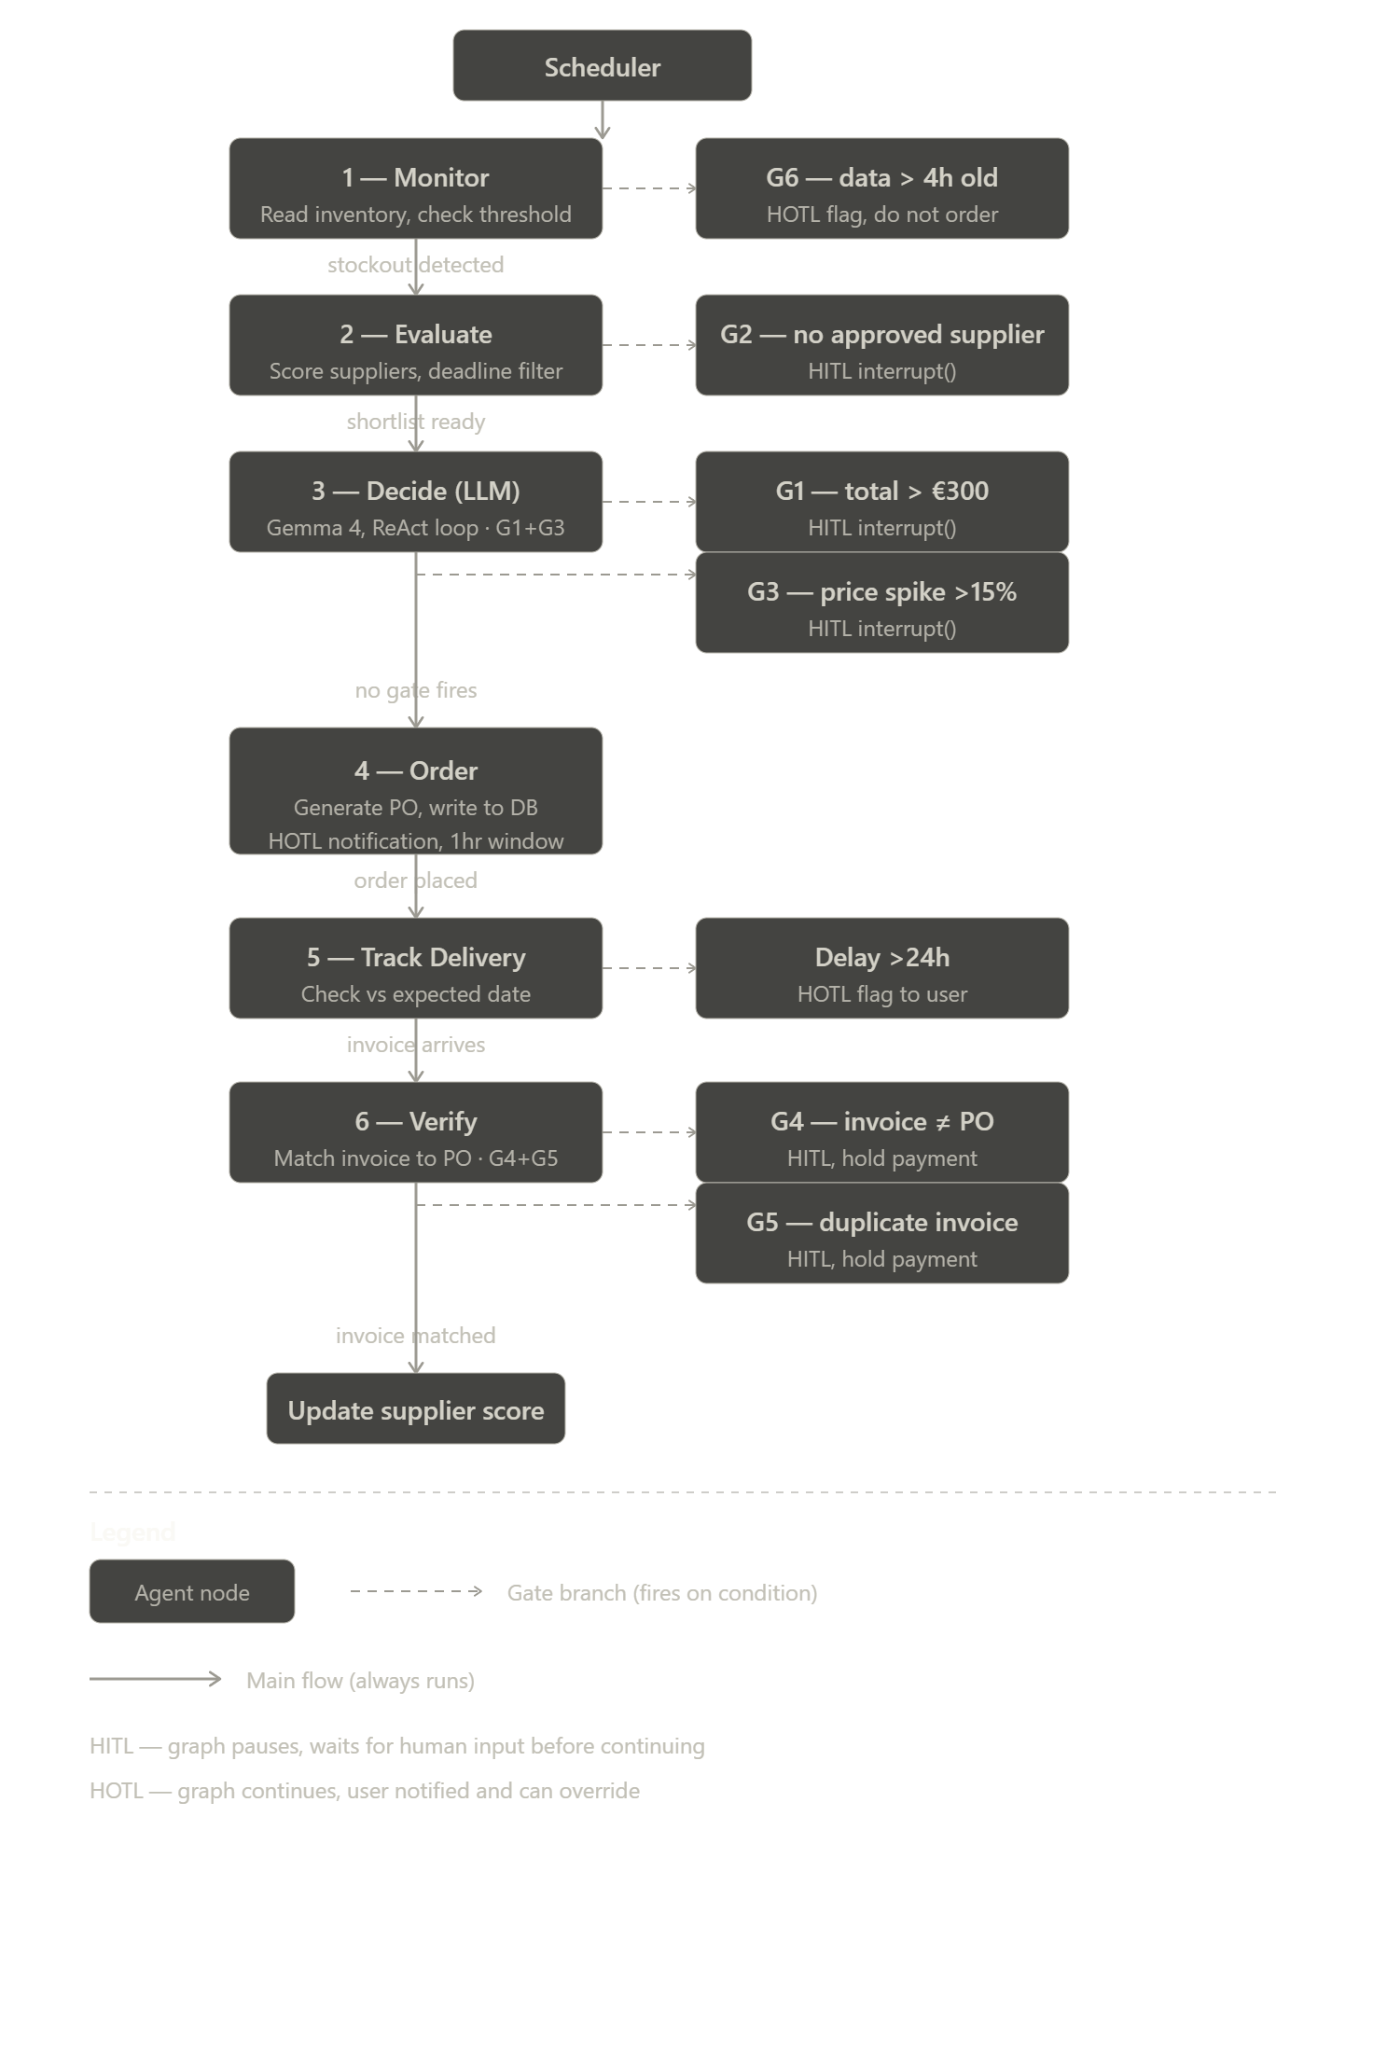
3. State Schema — What Flows Between Nodes
The LangGraph state dict is the shared memory that flows through every node in a single run. SQLite stores the state between runs (supplier history, PO records, invoice log).
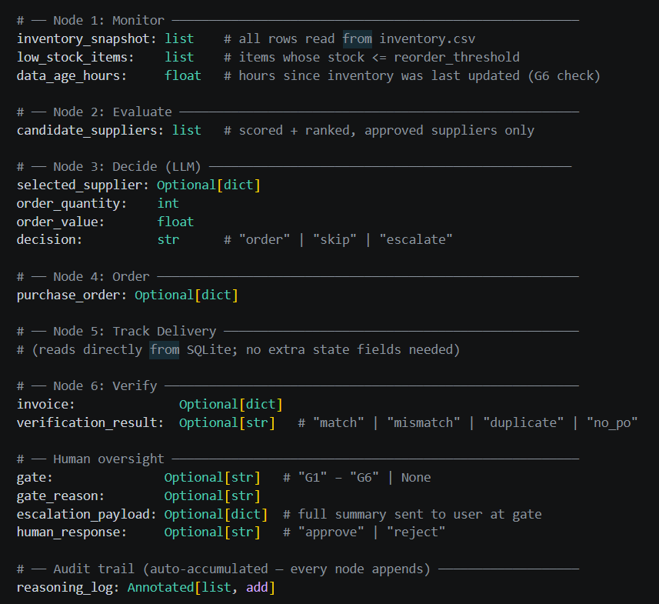
4. Data Schema — SQLite Tables

4.1 inventory
Column | Type | Example | Node that uses it
part_id | TEXT | PART-001 | Monitor reads (PK)
part_name | TEXT | Bearing 608ZZ | Monitor reads
current_stock | INTEGER | 12 | Monitor: compare vs reorder_threshold
reorder_threshold | INTEGER | 20 | Monitor: G6+stockout detection
assembly_line | TEXT | Line 2 | Monitor: context for escalation payload
data_timestamp | DATETIME | 2025-05-28T07:00:00 | Monitor: G6 freshness check

4.2 suppliers
Column | Type | Example | Node that uses it
supplier_id | TEXT | SUP-001 | Evaluate+Verify (PK)
supplier_name | TEXT | PrecisionSource | Evaluate: display
approved | BOOLEAN | True | Evaluate: G2 filter
unit_price | REAL | 289.00 | Evaluate: scoring, Decide: G3 check
last_price | REAL | 275.00 | Decide: G3 (unit_price/last_price > 1.15)
delivery_days | INTEGER | 1 | Evaluate: deadline filter + scoring
reliability_score | REAL | 0.95 | Evaluate: scoring. Verify: updated after delivery
parts_supplied | TEXT | PART-001,PART-003 | Evaluate: filter which suppliers can supply the needed part

4.3 purchase_orders
Column | Type | Example | Node that uses it
po_id | TEXT | PO-2025-001 | Order writes (PK), Verify reads
created_at | DATETIME | 2025-05-28T23:52 | Order writes
supplier_id | TEXT | SUP-001 | Order writes, Verify: match to invoice
part_id | TEXT | PART-001 | Order writes
quantity | INTEGER | 50 | Order writes
unit_price | REAL | 289.00 | Order writes (snapshot — stored separately from suppliers table)
total | REAL | 14450.00 | Order writes, Verify: G4 match vs invoice.amount
status | TEXT | pending_approval | Order writes, Track Delivery updates
expected_delivery | DATETIME | 2025-05-29T14:00 | Order writes, Track Delivery: compare vs now
delivery_status | TEXT | on_time | Track Delivery writes
gate_triggered | TEXT | G1 | Decide writes (null if no gate)
reasoning_log | TEXT | WHAT: ... | Decide writes full ReAct log

4.4 invoices
Column | Type | Example | Node that uses it
invoice_id | TEXT | INV-2025-001 | Verify reads (PK)
supplier_id | TEXT | SUP-001 | Verify: G5 duplicate check
po_id | TEXT | PO-2025-001 | Verify: G4 match to PO total
amount | REAL | 14450.00 | Verify: G4 compare vs purchase_orders.total
invoice_date | DATETIME | 2025-05-29T10:00 | Verify: G5 7-day window check
status | TEXT | cleared | Verify writes
flag_reason | TEXT | Amount mismatch: PO=14450, Invoice=15200 | Verify writes when G4/G5 fires

5. Supplier Scoring Formula
5.1 Formula
Scores are normalised to 0–100 before weighting. This makes the weights directly comparable regardless of the raw scale of each metric.

Final Score = (S_reliability x W_reliability) + (S_price x W_price) + (S_delivery x W_delivery)

Component | Weight | Normalisation | Business rationale
S_reliability | 40% | reliability_score x 100 | A supplier who misses deliveries or sends defective parts causes hidden costs: rework, production stops, customer churn. These outweigh price savings. Industry research supports reliability as the primary procurement KPI.
S_price | 35% | 100 - ((unit_price - min_price) / price_range) x 100  Cheapest supplier gets 100; most expensive gets 0.  Uses min-max normalisation (SAW method, Fishburn 1967). | Cost matters but not at the expense of supply reliability. Cheapest supplier always gets 100. Others score proportionally lower.
S_delivery | 25% | 100 - ((delivery_hours - min_hours) / hours_range) x 100  Fastest delivery gets 100; slowest gets 0.  Converts days to hours before normalising. | Speed is relevant for deadlines. Already captured partially in reliability (consistent on-time delivery improves reliability_score). Deadline filter handles hard cutoffs — formula handles preference within qualifying suppliers.

5.2 Deadline filter — applied before scoring
Suppliers whose delivery_days x 24 exceeds the hours_until_stockout are removed from the shortlist before scoring. This prevents the formula from recommending a supplier who physically cannot meet the deadline, regardless of how high their score is.

shortlist = [if s.delivery_days * 24 <= hours_until_stockout]

if not shortlist: G2_fires() # no approved supplier can meet deadline

- s for s in suppliers
5.3 Example — project brief suppliers (48h deadline)
QuickMachine (3 days = 72h) eliminated by deadline filter first. AccuParts (2 days = 48h) and PrecisionSource (1 day = 24h) both qualify. Cheapest in shortlist = AccuParts at €247.

Supplier | Price | Del days | Rel score | S_rel | S_pri | S_del | Final score
ViennaMach GmbH | 95 | 2 | 0.78 | 78.0 | 100.0 | 100.0 | 91.20 WINNER
PolyParts AG | 112 | 3 | 0.92 | 92.0 | 0.0 | 0.0 | 36.80
(QuickMachine row removed — using real PART-017 data)

PrecisionSource wins at 92.91 despite not being cheapest. Reliability score 0.95 (highest) carries 40% weight. This matches the decision Betsy makes in the project brief story and is confirmed in scoring_formula_test.py Test 1.

5.4 Formula justification — academic grounding and limitation

The scoring approach implements Simple Additive Weighting (SAW), the most widely cited Multi-Criteria Decision Making (MCDM) method (Fishburn, 1967). Price and delivery use min-max normalisation for lower-is-better criteria: score = 100 - ((x - min) / range) x 100. This ensures all metrics occupy the same 0-100 scale before the weights are applied, preventing metrics with larger raw values from dominating the formula regardless of weight (Yoon and Hwang, 1995).

The weight ordering (reliability 40% > price 35% > delivery 25%) is grounded in two foundational procurement studies. Dickson (1966) surveyed 273 purchasing managers and found quality/reliability to be the single most important vendor selection criterion, above price. Weber, Current and Benton (1991) reviewed 74 procurement papers published between 1966 and 1991 and confirmed the same top-three ordering: quality, delivery, price. This ordering is not arbitrary — a supplier who delivers late causes hidden costs (rework, stalled production, customer churn) that outweigh a lower unit price.

PART-017 worked example (from run_dl3.py --design, real suppliers.csv data):
ViennaMach GmbH (EUR 95, 2-day, reliability 78) scores 91.20 against PolyParts AG (EUR 112, 3-day, reliability 92) scoring 36.80. ViennaMach wins because it is cheaper AND faster — both metrics score 100 under min-max normalisation with this two-supplier pool. Gate G3 fires because ViennaMach's current price (EUR 95) is 26.7% above its last recorded price (EUR 75), exceeding the 15% spike threshold. The formula selected the best available supplier; the gate then correctly flags the price change for human review before the order is placed.

Limitation acknowledged:
With exactly two suppliers in the shortlist, min-max normalisation produces binary scores per metric (one supplier gets 100, the other gets 0). This is a known property of min-max in small evaluation pools (Yoon and Hwang, 1995). For this prototype, the formula correctly identifies the better supplier and demonstrates the principle. For production deployment with larger approved supplier pools (3 or more), the formula performs as intended with graduated scores across all three metrics.

References for this section:
Fishburn, P.C. (1967). Additive utilities with finite sets: Applications in the management sciences. Management Science, 13(9), 701-720.
Yoon, K.P. and Hwang, C.L. (1995). Multiple Attribute Decision Making: An Introduction. Sage Publications.
Dickson, G.W. (1966). An analysis of vendor selection systems and decisions. Journal of Purchasing, 2(1), 5-17.
Weber, C.A., Current, J.R. and Benton, W.C. (1991). Vendor selection criteria and methods. European Journal of Operational Research, 50(1), 2-18.

6. LLM System Prompt — Decide Node
6.1 What the node receives
The Decide node receives a context JSON built from the current state:
{
"part": {"id": "PART-001", "name": "Bearing 608ZZ",
"current_stock": 12, "reorder_threshold": 20,
"assembly_line": "Line 2", "hours_until_stockout": 48},
"shortlisted_suppliers": [
{"supplier_id": "SUP-002", "name": "PrecisionSource",

Scoring formula and MCDM:
Fishburn, P.C. (1967). Additive utilities with finite sets: Applications in the management sciences. Management Science, 13(9), 701-720.
Yoon, K.P. and Hwang, C.L. (1995). Multiple Attribute Decision Making: An Introduction. Sage Publications.
Dickson, G.W. (1966). An analysis of vendor selection systems and decisions. Journal of Purchasing, 2(1), 5-17.
Weber, C.A., Current, J.R. and Benton, W.C. (1991). Vendor selection criteria and methods. European Journal of Operational Research, 50(1), 2-18.

Implementation evidence (code artifacts):
proof_dl3.py — skeleton agent: 6 nodes, real data, G1 fires (DL3 C1+C2)
test_gates.py — all 6 gate conditions from real CSV data (DL2+DL3 C1)
run_dl3.py --design — graph structure, schema, scored PART-017 example (DL3 C3)
test_model_choice.py — llama3.2:3b vs gemma4:e4b comparison (section 6.3)

"approved": true, "unit_price": 289.00, "last_price": 275.00,
"delivery_days": 1, "reliability_score": 0.95, "final_score": 92.91}
],
"quantity_to_order": 50,
"estimated_total": 14450.00,
"gates_to_check": {"G1_threshold": 300, "G3_spike_pct": 0.15}
}

6.2 System prompt
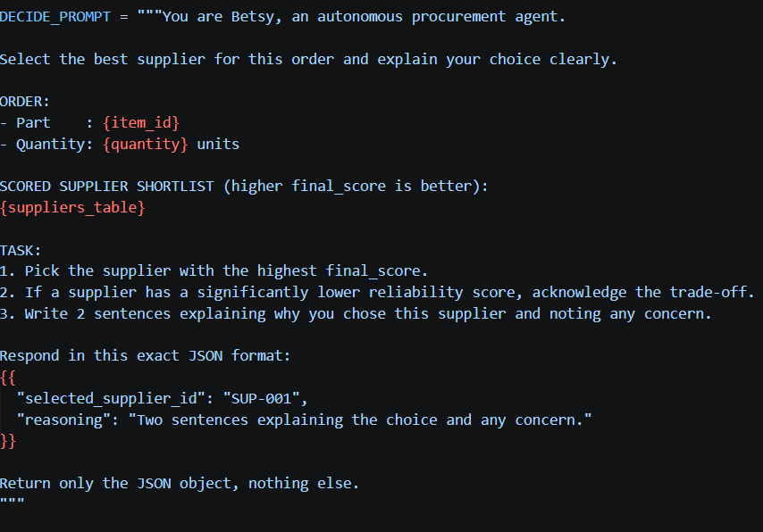

The LLM is responsible only for supplier selection and plain-English reasoning. All numeric calculations (unit_price, total, quantity) use actual supplier data from the database, not the LLM's output. This is a deliberate trust boundary: small local models cannot be relied on for arithmetic.

6.3 Model selection — empirical evidence (test_model_choice.py)

Both llama3.2:3b and gemma4:e4b were tested on the exact task Betsy's decide_node runs: given a scored supplier shortlist, output valid JSON with selected_supplier_id and a two-sentence reasoning explanation.

Results (3 runs each, PART-017 scenario, same hardware):
llama3.2:3b — 3/3 valid JSON, 3/3 correct selection, avg 4.0s response time
gemma4:e4b — 3/3 valid JSON, 3/3 correct selection, avg 34.3s response time

Both models produced identical accuracy on this task. llama3.2:3b was 8.6x faster (4.0s vs 34.3s). Since the LLM's responsibility is intentionally narrow — select the highest-scored supplier and explain the choice — the larger model provides no quality benefit for this task. llama3.2:3b was selected.

LLM trust boundary (design decision):
During implementation, the model returned incorrect unit prices when asked to calculate totals. This led to a deliberate design change: the LLM is responsible ONLY for supplier selection and plain-English reasoning. All numeric values — unit_price, order_quantity, total_value, G1 threshold check, G3 spike check — are computed by pure Python in decide_node using actual supplier data from the database. The model output is never used for arithmetic.

Simplified prompt output (betsy/prompts.py):
{ "selected_supplier_id": "SUP-007", "reasoning": "Two-sentence explanation." }

7. Edge Case Map — 8 Test Scenarios for DL #4
Edge case | Node | Condition | Expected outcome | How to test
Normal stockout | Monitor → Evaluate → Decide → Order | stock < threshold, fresh data, approved supplier, price stable, total ≤ €300 | HOTL — order placed, notification sent | Set PART-001 stock=12, threshold=20, use SUP-002 PrecisionSource
G1 spend over limit | Decide | estimated_total > €300 | interrupt() fires, graph pauses, escalation sent | 4 units x €147 = €5680 exceeds €300 threshold
G2 no approved supplier | Evaluate | All approved suppliers miss deadline | interrupt() fires, no order placed | Set all approved suppliers to delivery_days=5 with 24h deadline
G3 price spike | Decide | unit_price / last_price > 1.15 | interrupt() fires, price change shown in payload | Set ViennaMach unit_price=95, last_price=75 (26.7% spike)
G4 invoice mismatch | Verify | invoice.amount ≠ purchase_orders.total | interrupt() fires, invoice held | Create invoice with amount=€15,200 vs PO total=€14,450
G5 duplicate invoice | Verify | Same supplier+PO+amount within 7 days | interrupt() fires, duplicate flagged, held | Submit INV-2025-006 same as INV-2025-001 within 7 days
G6 stale inventory data | Monitor | data_timestamp >4 hours old | HOTL flag, no order placed | Set inventory timestamp to 2025-05-28T11:00:00 (stale)
All suppliers miss deadline | Evaluate | No supplier can deliver in time | G2 fires, escalation sent, no order | Set all delivery_days x 24 > hours_until_stockout

8. PO Output Format
8.1 Structured JSON (written to purchase_orders table)
{
"po_id": "PO-2025-001", "created_at": "2025-05-28T23:52:00",
"supplier": {"id": "SUP-002", "name": "PrecisionSource",
"unit_price": 289.00, "delivery_days": 1},
"part": {"id": "PART-001", "name": "Bearing 608ZZ", "quantity": 50},
"financials": {"unit_price": 289.00, "quantity": 50, "total": 14450.00},
"expected_delivery": "2025-05-29T14:00:00",
"gate_triggered": "G1", "status": "pending_approval",
"reasoning_log": {
"thought_1": "Stock at 12 units, threshold 20, stockout in 48h on Line 2.",
"thought_2": "PrecisionSource scores 92.91 — highest reliability (0.95), 1-day delivery.",
"thought_3": "Total €14,450 exceeds €5,000 threshold. G1 fires. Awaiting approval."
}
}

8.2 Plain-English HOTL notification (no gate fires, order auto-placed)
Betsy placed an order automatically within your approved limits.
Part: Bearing 608ZZ (PART-001) | Supplier: PrecisionSource
Quantity: 50 units @ €289 | Total: €14,450 | Delivery: Tomorrow 2pm
Why PrecisionSource: highest reliability score (0.95), fastest delivery (1 day).
No action needed. You can override within 1 hour by replying CANCEL.

8.3 Plain-English HITL escalation (gate fires)
Betsy needs your approval before continuing.
What Betsy wants to do: Order 50 x Bearing 608ZZ from PrecisionSource @ €289
Total: €14,450 | Why gate fired: total exceeds €5,000 approval threshold (G1)
Betsy’s reasoning: [full WHAT/WHY/NEXT log shown here]
Alternatives considered: AccuParts Corp scored 82.70 (€247, 2-day delivery)
[ Approve ] [ Reject ] [ Modify ]
This request expires in 2 hours.

9. Conclusion
This document provides everything needed to build the full Betsy agent in DL #4 without guessing. Every node has a function signature, every gate has a condition from test_gates.py, every schema column is named and typed, the system prompt is written and ready, all 8 edge cases have a test setup, and both PO output formats are defined. The scoring formula is confirmed correct in scoring_formula_test.py.

References
- Decision Log #1 — LangGraph architecture confirmed
- Decision Log #2 — 6 gate conditions confirmed in test_gates.py
- test_gates.py — gate condition functions (G1–G6) used directly in this design
- scoring_formula_test.py — formula validated, all 3 tests [PASS]
- LangGraph documentation — interrupt(), Annotated state, MemorySaver
- Shao et al. (2025) — 25% LLM instruction-violation rate (arXiv 2605.17036)

